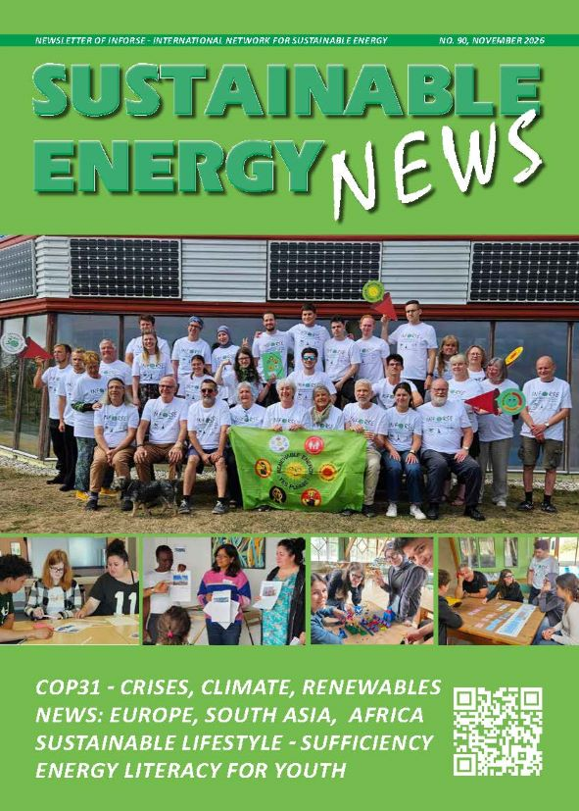
Sustainable Energy News No. 90, November 2026
Newsletter of INFORSE, International Network for Sustainable Energy

https://www.inforse.org/doc/SEN90.pdf
More:
https://www.inforse.org/europe/news-fr.htm and
https://www.inforse.org/s_e_news.php3

EDITORIAL p. 2
In a World Full of Crises, Solutions are Near
GLOBAL p. 3
International Cooperation for Sustainable Energy Systems
- INFORSE at COP31
- Don't Nuke the Climate
Europe
Sufficiency as Climate Action pp. 4-5
NGO Cooperation Project in Nordic & Baltic Countries & Belarus
Energy Literacy for Youth pp. 6-7
European NGO Cooperation Project Creating a Participatory Curriculum
News: Europe pp. 8-9
INFORSE-Europe News:
- European Sustainable Energy NGO Seminar in Denmark, August 2026.
- Enabling Windpower through Local Trust
- UK, Wales: CAT
- Germany: Artefact
- Hungary: Energiaklub
- New Members: from Italy & Romania
News: Canada p. 9
- Heat Pump Campaign
News Africa p 10.
- Tanzania: TaTEDO
- Uganda: JEEP
- Mali: Mali Folkecenter
- Online Catalogues of Local Solutions
News South Asia p. 11
- Bangladesh: CCDB
- Nepal: PRC & CRT-N
- Online Database of Local Solutions of Eco-Village Development
BACK PAGE p. 12
About INFORSE

– Social Media
https://www.inforse.org/
https://www.facebook.com/INFORSE - https://www.linkedin.com/company/inforse
https://bsky.app/profile/inforse.bsky.social -

