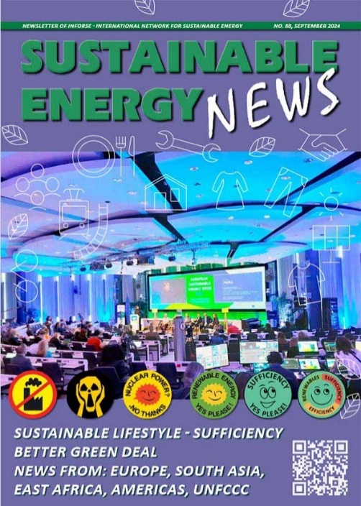
Sustainable Energy News No. 88, September 2024
Newsletter of INFORSE, International Network for Sustainable Energy
https://www.inforse.org/doc/SEN88.pdf
More:
https://www.inforse.org/europe/news-fr.htm and
https://www.inforse.org/s_e_news.php3
EDITORIAL p. 2
New Policies and Actions for Climate Urgency
GLOBAL p. 3
- The Global Climate Action We Need
- INFORSE at COP29
- Don't Nuke the Climate
THEME: FULFILL- SUFFICIENCY.EU pp. 4-7
Sufficiency - Decarbonization through Lifestyle Changes & Wellbeing for All Within Planetary Boundaries
Research Results of the FULFILL EU Horizon2020 Project - Researching Sufficiency - barriers, enablers, benefits, co-benefits in food, housing, transport and consumption. Project partners: Fraunhofer ISI (coord) | INFORSE-Europe | Association négaWatt | Jacques Delors Institute, Wuppertal Institute for Climate, Environment and Energy | Politecnico di Milano | Eurac Research | Green Liberty.
THEME: Europe - Better Green Deal pp. 8-10
Better Green Deal, Better Climate Mitigation Policies in Baltic Countries - Latvia, Lithuania, Denmark, Sweden, Norway, and Belarus, Ukraine. Project supported by NCM. Project partners: INFORSE-Europe (coord) | Latvian Green Movement | AirClim | Circular Economy | Norges Naturvernforbund | Ecohome | Ecoaction.
INFORSE-Europe Sustainable Energy Seminar and General Meeting in Latvia: September 25-27 and 28, 2024
NEWS FROM MEMBERS:
News: Europe pp. 11-12
- INFORSE-Europe in New Climate-Energy Education Project for Youth
- UK, Wales: Centre for Alternative Technology (CAT) - Study at CAT
- Germany: Artefact - Solar Car Race Raises Youth Interest on Renewable Technology
- Denmark: VE/SE, Samsø EA/SMEK, Nordic Folkecenter for Renewable Energy Organise Debates on EU
- Nordic Folkecenter for Renewable Energy Active in Denmark and in Mali and Uganda
- INFORSE-Europe on New Ecodesign
- Hungary: EPEN Assists Community Energy Planning in a Hilly Area
News Americas p. 12
- USA: Solar Cookers International Published New Research on Testing Efficiency of Solar Cookers
- Latin America: Renewable Energy Generation is Booming. Now Local Solutions are on the Way - Discussed on a Regional CSO Meeting in Columbia
- Canada: Heat Pumps are in Focus by We c.a.r.e – NetZeroPLUS.
News South Asia p 13.
- Bangladesh: A New Climate Demonstration and Training Center at an INFORSE member
- India: All India Women Conference (AIWC) and INFORSE Strengthen Cooperation
- South Asia: Grameen Shakti (Bangladesh), CRT (Nepal), INSEDA (India), IDEA (Sri Lanka), DIB (Denmark)- WePOWER and Eco-Village Development Database.
News East Africa p. 14
- Uganda: UCSD & Joint Energy and Environment Projects (JEEP) Green Manifesto to Make Nebbi Green - Questions to Candidates for Local Election.
- Tanzania: TAREA Invites to Webinar on Institutional Solar PV Kitchen
Publications: p. 15
Online Catalogues of Local Solutions in East Africa, South Asia, Europe, and Ukraine
https://localsolutions.inforse.org/ https://inforse.org/evd/ https://www.inforse.org/europe/educat.htm
https://www.inforse.org/europe/SELNEE.htm
BACK PAGE p. 16 - INFORSE's description & Contacts – https//www.inforse.org

